Part 1
Task1: Implement a Library Book Search System using Arrays
Code:
#include <iostream>
#include <string>
using namespace std;

bool LinearSearch(string arr[], int n, string target, int &index)
{
for (int i = 0; i < n; i++)
{
if (arr[i] == target)
{
index = i;
return true;
}
}
return false;
}

bool binarySearch(string arr[], int n, string target, int &index)
{
int low = 0;
int high = n - 1;
while (low <= high)
{
int mid = (low + high) / 2;
if (arr[mid] == target)
{
index = mid;
return true;
}
else if (arr[mid] < target)
{
low = mid + 1;
}
else
{
high = mid - 1;
}
}
return false;
}

void bubbleSort(string arr[], int n)
{
bool sorted;
int i = 0;
do
{
sorted = false;
for (int j = 0; j < n - 1 - i; j++)
{
if (arr[j] > arr[j + 1])
{
swap(arr[j], arr[j + 1]);
sorted = true;
}
}
i++;
} while (sorted);
}

int main()
{
string books[] = {"DSA", "Linear", "Theory of Automata", "C++",
"Python", "TypeScript", "NextJS"};
int n = sizeof(books) / sizeof(books[0]);

string sortedBooks[8];
for (int i = 0; i < n; i++)
{
sortedBooks[i] = books[i];
}
bubbleSort(sortedBooks, n);

string searchBook = "NextJS";
int index;

cout << "Library Book Search System\n\n";
cout << "Searching for: " << searchBook << "\n\n";

if (LinearSearch(books, n, searchBook, index))
{
cout << "Linear Search: Found at index " << index << "\n";
}
else
{
cout << "Linear Search: Not found\n";
}

if (binarySearch(sortedBooks, n, searchBook, index))
{
cout << "Binary Search: Found at index " << index << "\n";
}
else
{
cout << "Binary Search: Not found\n";
}

return 0;
}
Output:
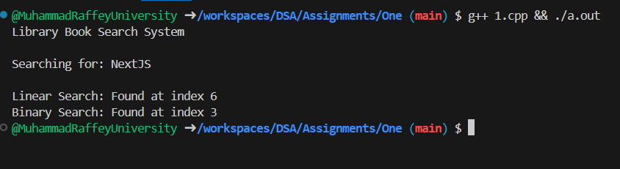

Task 2: Sort the Library
Code:
#include <iostream>
#include <string>
using namespace std;

void selectionSort(string arr[], int n)
{
for (int i = 0; i < n - 1; i++)
{
int minIdx = i;
for (int j = i + 1; j < n; j++)
{
if (arr[j] < arr[minIdx])
{
minIdx = j;
}
}
if (minIdx != i)
{
swap(arr[i], arr[minIdx]);
}
}
}

void bubbleSort(string arr[], int n)
{
for (int i = 0; i < n - 1; i++)
{
for (int j = 0; j < n - 1 - i; j++)
{
if (arr[j] > arr[j + 1])
{
swap(arr[j], arr[j + 1]);
}
}
}
}

void display(string arr[], int n)
{
for (int i = 0; i < n; i++)
{
cout << arr[i] << endl;
}
}

int main()
{
string books[] = {"DSA", "Linear", "Theory of Automata", "C++",
"Python", "TypeScript", "NextJS"};

int n = sizeof(books) / sizeof(books[0]);

cout << "Selection Sort:\n";
selectionSort(books, n);
display(books, n);

cout << "\nBubble Sort:\n";
bubbleSort(books, n);
display(books, n);

return 0;
}
Output:
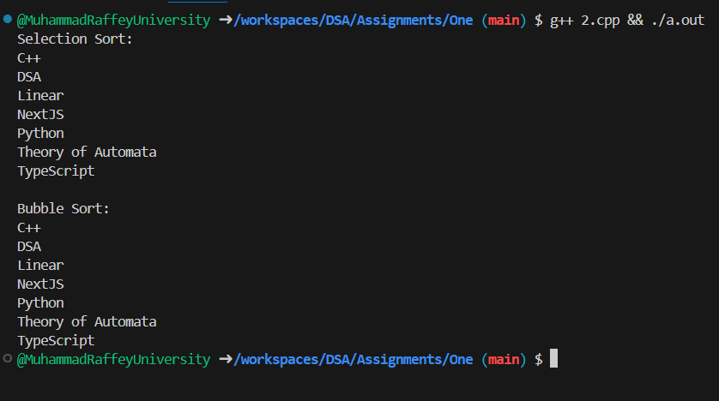

Part 2
Task3: Implement a Library Book Search System using a link list
Code:
#include <iostream>
#include <string>
using namespace std;

class Node
{
public:
string data;
Node *next;
Node(string val) : data(val), next(NULL) {}
};

class LinkedList
{
private:
Node *head;

public:
LinkedList()
{
head = NULL;
}

void insertAtEnd(string value)
{
Node *newNode = new Node(value);

if (head == NULL)
{
head = newNode;
return;
}

Node *temp = head;
while (temp->next != NULL)
{
temp = temp->next;
}
temp->next = newNode;
}

int searchBook(string bookTitle)
{
Node *temp = head;
int position = 1;

while (temp != NULL)
{
if (temp->data == bookTitle)
{
return position;
}
temp = temp->next;
position++;
}
return -1;
}

void display()
{
Node *temp = head;
while (temp != NULL)
{
cout << temp->data << endl;
temp = temp->next;
}
}
};

int main()
{
LinkedList library;

library.insertAtEnd("DSA");
library.insertAtEnd("Linear");
library.insertAtEnd("Theory of Automata");
library.insertAtEnd("C++");
library.insertAtEnd("Python");
library.insertAtEnd("TypeScript");
library.insertAtEnd("NextJS");

cout << "Library Books:\n";
library.display();

string searchBook = "Python";
int position = library.searchBook(searchBook);

cout << "\nSearching for: " << searchBook << endl;
if (position != -1)
{
cout << "Found at position: " << position << endl;
}
else
{
cout << "Not found" << endl;
}

return 0;
}
Output:
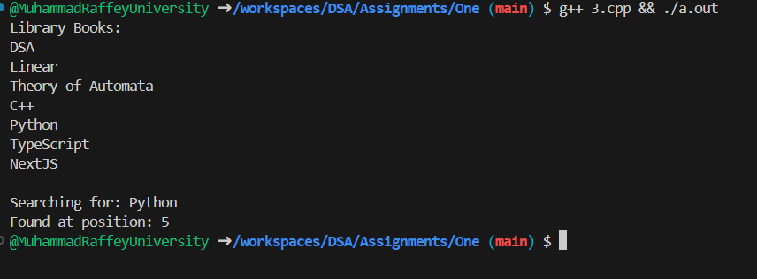

Task4 Library Management System
Code:
#include <iostream>
#include <string>
using namespace std;

class Node
{
public:
string data;
Node *next;
Node(string val) : data(val), next(NULL) {}
};

class WaitingList
{
private:
Node *head;

public:
WaitingList()
{
head = NULL;
}

void addToWaitingList(string name)
{
Node *newNode = new Node(name);
if (head == NULL)
{
head = newNode;
return;
}
Node *temp = head;
while (temp->next != NULL)
{
temp = temp->next;
}
temp->next = newNode;
}

void displayWaitingList()
{
if (head == NULL)
{
cout << "No one in waiting list\n";
return;
}
Node *temp = head;
int position = 1;
while (temp != NULL)
{
cout << position << ". " << temp->data << endl;
temp = temp->next;
position++;
}
}
};

bool searchBook(string arr[], int n, string target, int &index)
{
for (int i = 0; i < n; i++)
{
if (arr[i] == target)
{
index = i;
return true;
}
}
return false;
}

void bubbleSort(string arr[], int n)
{
for (int i = 0; i < n - 1; i++)
{
for (int j = 0; j < n - 1 - i; j++)
{
if (arr[j] > arr[j + 1])
{
swap(arr[j], arr[j + 1]);
}
}
}
}

void printBooks(string arr[], int n)
{
for (int i = 0; i < n; i++)
{
cout << i + 1 << ". " << arr[i] << endl;
}
}

int main()
{
string books[] = {"DSA", "Linear", "Theory of Automata", "C++",
"Python", "TypeScript", "NextJS"};
int n = 7;
WaitingList waitingList;
cout << "=== Library Management System ===\n\n";
cout << "Available Books:\n";
printBooks(books, n);
cout << "\n--- Searching for a Book ---\n";
string searchTitle = "Python";
int index;
if (searchBook(books, n, searchTitle, index))
{cout << "'" << searchTitle << "' found at position " << (index + 1) << endl;}
else
{cout << "Book not found\n";}
cout << "\n--- Sorting Books ---\n";
string sortedBooks[7];
for (int i = 0; i < n; i++)
{sortedBooks[i] = books[i];}
bubbleSort(sortedBooks, n);
cout << "Books in alphabetical order:\n";
printBooks(sortedBooks, n);
cout << "\n--- Waiting List for 'DSA' ---\n";
waitingList.addToWaitingList("Raffey");
waitingList.addToWaitingList("Annas");
waitingList.addToWaitingList("Junaid");
waitingList.displayWaitingList();
return 0;}
Output:
